I want to record a strange thing that happens when I’m doing Homework 4.

I want to define the layers in Residual_block in a flexible way, that once the parameters for each layer are provided (no matter how long), it’ll be able to define the layers and run them.

However, the following commands are correct:



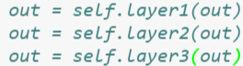



While the following one will fail to define the variables or run the code so errors will be raised:



